The Alde River Benefice

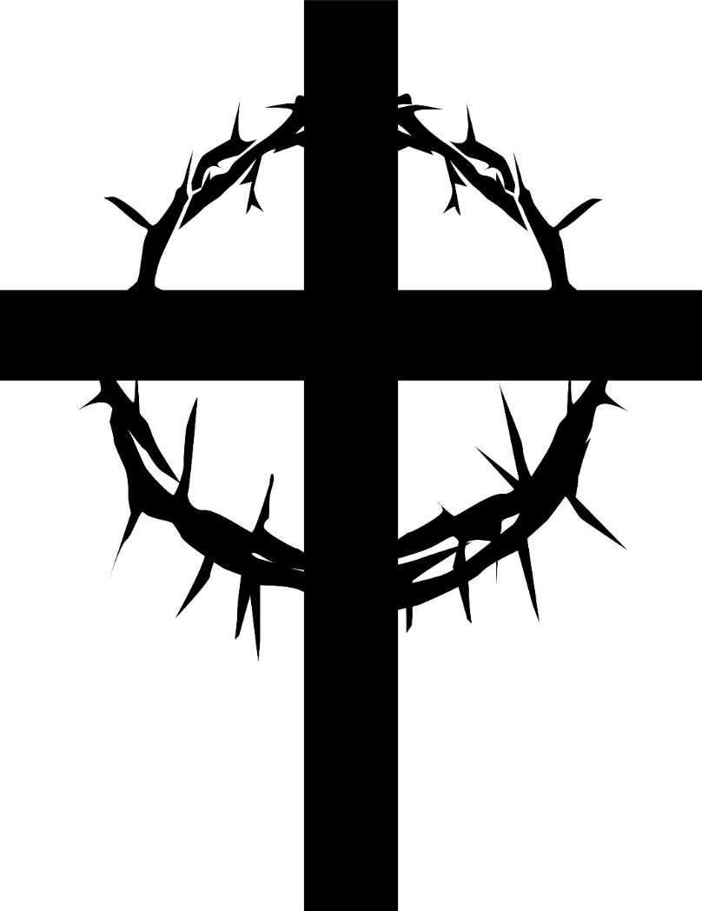

Holy Communion in Lent

Common Worship: Services and Prayers for the Church of England, material from which is included in this service, is © Copyright The Archbishops’ Council 2000.
Common Worship: Times and Seasons, material from which is included in this service, is © Copyright The Archbishops’ Council 2006.

¶ The Gathering
Welcome and Notices

Hymn
In the name of the Father, and of the Son, and of the Holy Spirit.
All Amen.

The Greeting
The Lord be with you
All and also with you.

Prayer of Preparation

All Almighty God, to whom all hearts are open, all desires known,
and from whom no secrets are hidden:
cleanse the thoughts of our hearts
by the inspiration of your Holy Spirit,
that we may perfectly love you,
and worthily magnify your holy name; through Christ our Lord.
Amen.

Prayers of Penitence
Compassion and forgiveness belong to the Lord our God,
though we have rebelled against him.
Let us then renounce our wilfulness and ask his mercy
by confessing our sins in penitence and faith.

Silence

Lord Jesus Christ,
we confess we have failed you as did your first disciples.
We ask for your mercy and your help.

Our selfishness betrays you:
Lord, forgive us.
All Christ have mercy.

We fail to share the pain of your suffering:
Lord, forgive us.
All Christ have mercy.

We run away from those who abuse you:
Lord, forgive us.
All Christ have mercy.

We are afraid of being known to belong to you:
Lord, forgive us.
All Christ have mercy.

Absolution
Almighty God, who forgives all who truly repent,
have mercy upon you, pardon and deliver you from all your sins,
confirm and strengthen you in all goodness,
and keep you in life eternal; through Jesus Christ our Lord.
All Amen.

The Collect
The Collect is said and all respond
All Amen.
¶ The Liturgy of the Word
Reading
At the end the reader say’s:
This is the word of the Lord.
All Thanks be to God.

Hymn

Gospel Reading
When the Gospel is announced the reader says
Hear the Gospel of our Lord Jesus Christ according to N.
All Glory to you, O Lord.

at the end
This is the Gospel of the Lord.
All Praise to you, O Christ.

Sermon

The Creed
Let us declare our faith in God, Father, Son and Holy Spirit.

All We believe in one God, the Father, the Almighty,
maker of heaven and earth, of all that is, seen and unseen.

We believe in one Lord, Jesus Christ, the only Son of God,
eternally begotten of the Father,
God from God, Light from Light,
true God from true God, begotten, not made,
of one Being with the Father;
through him all things were made.
For us and for our salvation he came down from heaven,
was incarnate from the Holy Spirit and the Virgin Mary
and was made man.
For our sake he was crucified under Pontius Pilate;
he suffered death and was buried.
On the third day he rose again
in accordance with the Scriptures;
he ascended into heaven
and is seated at the right hand of the Father.
He will come again in glory to judge the living and the dead,
and his kingdom will have no end.

We believe in the Holy Spirit, the Lord, the giver of life,
who proceeds from the Father and the Son,
who with the Father and the Son is worshipped and glorified,
who has spoken through the prophets.
We believe in one holy catholic and apostolic Church.
We acknowledge one baptism for the forgiveness of sins.
We look for the resurrection of the dead,
and the life of the world to come. Amen.

Prayers of Intercession
The prayers may include one of these responses
Lord, in your mercy (or) Let us pray to the Lord
All hear our prayer. All Lord have mercy

The prayers end with

Merciful Father,
All accept these prayers for the sake of your Son,
our Saviour Jesus Christ.
Amen.
¶ The Liturgy of the Sacrament
The Peace
Since we are justified by faith,
we have peace with God through our Lord Jesus Christ,
who has given us access to his grace.

The peace of the Lord be always with you
All and also with you.

Let us offer one another a sign of peace.
All may exchange a sign of peace.

Preparation of the Table
Taking of the Bread and Wine

Hymn
The gifts of the people may be gathered and presented.
The table is prepared and bread and wine are placed upon it.
God of mercy and compassion,
your Word calls us home to faith and love.
accept all we offer you this day;
in the name of Jesus Christ the Lord.
All Amen.

Eucharistic Prayer
The Lord be with you
All and also with you.
Lift up your hearts.
All We lift them to the Lord.
Let us give thanks to the Lord our God.
All It is right to give thanks and praise.

It is indeed right and good to give you thanks and praise,
almighty God and everlasting Father,
through Jesus Christ your Son.
For in these forty days you lead us into the desert of repentance
that through a pilgrimage of prayer and discipline we may grow in grace and learn to be your people once again.
Through fasting, prayer and acts of service
you bring us back to your generous heart.
Through study of your holy word
you open our eyes to your presence in the world
and free our hands to welcome others
into the radiant splendour of your love.
As we prepare to celebrate the Easter feast
with joyful hearts and minds we bless you for your mercy
and join with saints and angels for ever praising you and saying:

All Holy, holy, holy Lord, God of power and might,
heaven and earth are full of your glory.
Hosanna in the highest.
Blessed is he who comes in the name of the Lord.
Hosanna in the highest.

Lord, you are holy indeed, the source of all holiness;
grant that by the power of your Holy Spirit,
and according to your holy will, these gifts of bread and wine
may be to us the body and blood of our Lord Jesus Christ;

who, in the same night that he was betrayed,
took bread and gave you thanks;
he broke it and gave it to his disciples, saying:
Take, eat; this is my body which is given for you;
do this in remembrance of me.

In the same way, after supper
he took the cup and gave you thanks; he gave it to them, saying:
Drink this, all of you; this is my blood of the new covenant,
which is shed for you and for many for the forgiveness of sins.
Do this, as often as you drink it, in remembrance of me.

Christ is the bread of life:
All When we eat this bread and drink this cup,
we proclaim your death, Lord Jesus, until you come in glory.

And so, Father, calling to mind his death on the cross,
his perfect sacrifice made once for the sins of the whole world;
rejoicing in his mighty resurrection and glorious ascension,
and looking for his coming in glory,
we celebrate this memorial of our redemption.
As we offer you this our sacrifice of praise and thanksgiving,
we bring before you this bread and this cup
and we thank you for counting us worthy
to stand in your presence and serve you.
Send the Holy Spirit on your people and gather into one in your kingdom all who share this one bread and one cup,
so that we, in the company of all the saints,
may praise and glorify you for ever, through Jesus Christ our Lord;

by whom, and with whom, and in whom, in the unity of the Holy Spirit, all honour and glory be yours, almighty Father,
for ever and ever.
All Amen.

The Lord’s Prayer
Trusting in the compassion of God, Sit or Kneel
let us pray with confidence as our Saviour has taught us

All Our Father, who art in heaven, hallowed be thy name;
thy kingdom come; thy will be done; on earth as it is in heaven.
Give us this day our daily bread.
And forgive us our trespasses,
as we forgive those who trespass against us.
And lead us not into temptation; but deliver us from evil.
For thine is the kingdom, the power and the glory,
for ever and ever. Amen.

Breaking of the Bread
We break this bread to share in the body of Christ.
All Though we are many, we are one body,
because we all share in one bread.

Agnus Dei
All Lamb of God, you take away the sin of the world,
have mercy on us.
Lamb of God, you take away the sin of the world,
have mercy on us.
Lamb of God, you take away the sin of the world,
grant us peace.
Giving of Communion
Jesus is the Lamb of God who takes away the sin of the world.
Blessed are those who are called to his supper.
All Lord, I am not worthy to receive you,
but only say the word, and I shall be healed.

The president and people receive communion.

The body of Christ, broken for you.
The blood of Christ, shed for you.

Prayer after Communion
Silence is kept.

The post communion prayer is said and all respond
All Amen.

All Almighty God, we thank you for feeding us
with the body and blood of your Son Jesus Christ.
Through him we offer you our souls and bodies
to be a living sacrifice. Send us out in the power of your Spirit
to live and work to your praise and glory. Amen.
¶ The Dismissal
Hymn

Responsory
This is love, not that we loved God,
All but that he loved us and sent his Son.
He is the sacrifice for our sins,
All that we might live through him.
If God loves us so much
All we ought to love one another.
If we love one another
All God lives in us.

Blessing
Christ give you grace to grow in holiness,
to deny yourselves, take up your cross, and follow him;
and the blessing of God almighty,
the Father, the Son, and the Holy Spirit,
be among you and remain with you always.
All Amen.

Go in peace to love and serve the Lord.
All In the name of Christ. Amen.

